SIMATS ENGINEERING
ASSESSMENT TOOL 1
COURSE NAME: Cryptography and Network Security
COURSE CODE: CS A5113

COURSE OUTCOME COVERED
CO3: Examine cryptographic hash algorithms, digital signature schemes, and assess
Kerberos and X.509 authentication frameworks for ensuring integrity, authentication, and
non-repudiation.CO (BL4 , BL5)
Assessment Tool Weightage: 40%
QUESTIONS: 5 TOTAL MARKS: 25

EXPERIMENTS

Annexure A
Experiments

1. Implement and compare MD5 and Secure Hash Algorithm (SHA-256) in Python by
hashing multiple input messages. Analyze their collision resistance and
performance differences.

2. Develop a Python program to implement a Digital Signature scheme using RSA.
Demonstrate message signing and signature verification, and analyze its
effectiveness in ensuring integrity and authentication.

3. Write a Python program to simulate HMAC (Hash-based Message Authentication
Code) using a chosen hash function. Compare its security properties with a simple
hash-based integrity check.

4. Implement a simplified Kerberos authentication mechanism in Python to simulate
ticket generation, distribution, and validation between a client and server. Analyze
its effectiveness in preventing replay attacks.

5. Develop a Python-based implementation of either the ElGamal or Schnorr digital
signature scheme, and evaluate its security features compared to standard digital
signature approaches.

EXPERIMENT 1: MD5 AND SHA-256 COMPARISON

Program
import hashlib
import time

messages = [
"Hello World",
"Cyber Security",
"Digital Signature",
"Kerberos Authentication",
"HMAC Security"
]

print("MD5 vs SHA-256 Comparison")
print("=" * 60)

for message in messages:

data = message.encode()

# MD5
start = time.perf_counter()
md5_hash = hashlib.md5(data).hexdigest()
md5_time = time.perf_counter() - start

# SHA-256
start = time.perf_counter()
sha_hash = hashlib.sha256(data).hexdigest()
sha_time = time.perf_counter() - start

print("\nMessage:", message)
print("MD5 Hash :", md5_hash)
print("SHA-256 Hash :", sha_hash)
print("MD5 Time :", md5_time)
print("SHA-256 Time :", sha_time)

print("\nSecurity Analysis")
print("MD5 : 128-bit output, collision attacks are known")
print("SHA-256 : 256-bit output, significantly stronger collision resistance")

OUTPUT

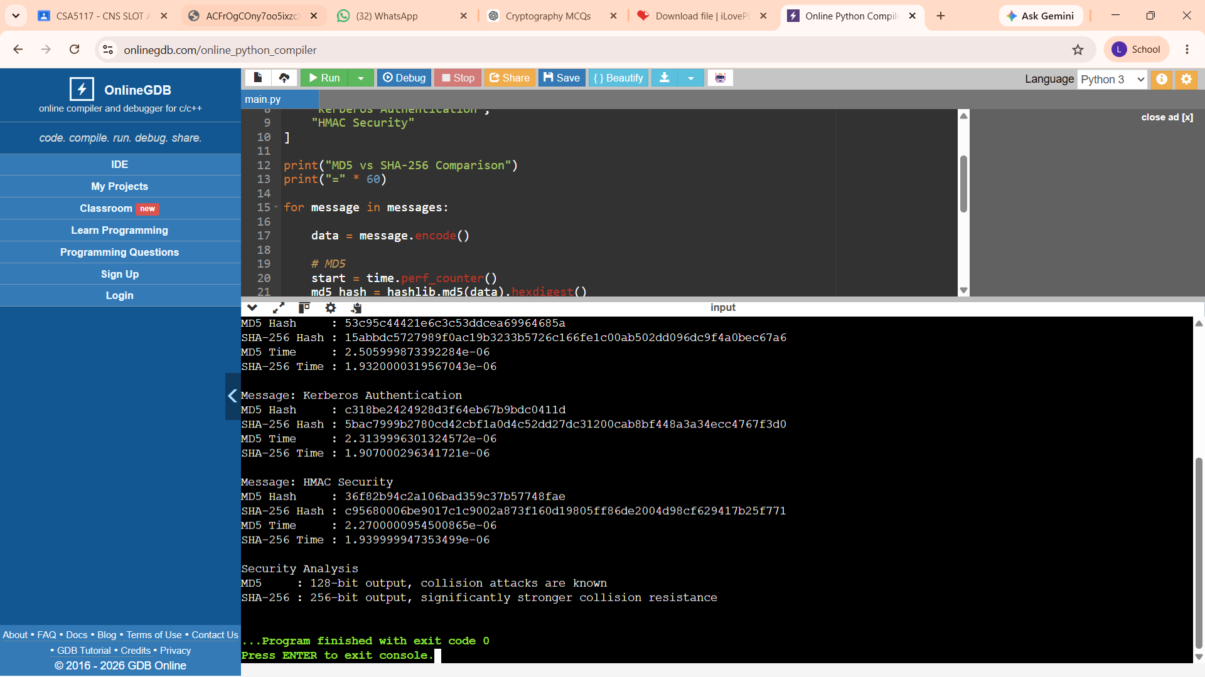

EXPERIMENT 2: RSA DIGITAL SIGNATURE
Program
import hashlib

# Small parameters for demonstration only
p = 61
q = 53

n = p * q
phi = (p - 1) * (q - 1)

e = 17
d = pow(e, -1, phi)

print("Public Key :", (e, n))
print("Private Key:", (d, n))

message = "This is a secure transaction"

# SHA-256 hash
hash_value = hashlib.sha256(message.encode()).hexdigest()

# Convert hash into integer
hash_int = int(hash_value, 16) % n

# Generate signature using private key
signature = pow(hash_int, d, n)

print("\nOriginal Message:", message)
print("SHA-256 Hash:", hash_value)
print("Digital Signature:", signature)

# Verify signature
verified_hash = pow(signature, e, n)

if verified_hash == hash_int:
print("Signature Verification: SUCCESS")
else:
print("Signature Verification: FAILED")

# Modify message
modified_message = "This is a modified transaction"

modified_hash = int(
hashlib.sha256(modified_message.encode()).hexdigest(),
16
) % n

if verified_hash == modified_hash:
print("Modified Message: VERIFIED")
else:
print("Modified Message: REJECTED")

OUTPUT
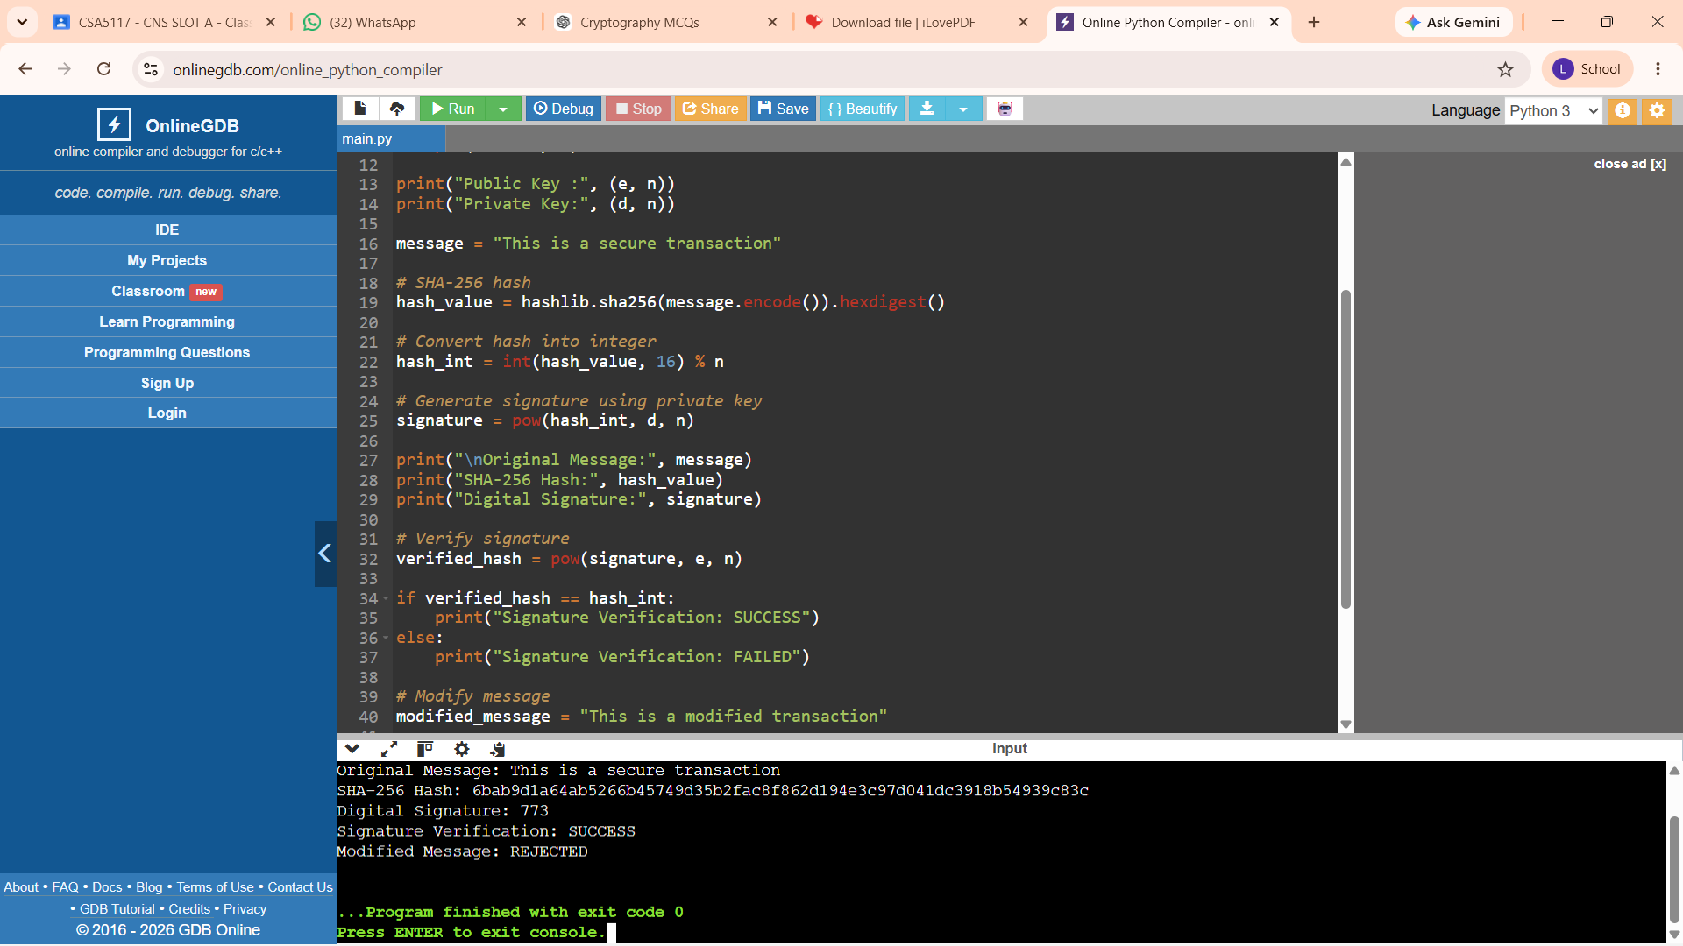
EXPERIMENT 3: HMAC IMPLEMENTATION
Program
import hashlib
import hmac

message = "Transfer Rs.5000 to Account A"
secret_key = b"my_secure_secret_key"

# Simple SHA-256
simple_hash = hashlib.sha256(
message.encode()
).hexdigest()

# HMAC-SHA-256
hmac_value = hmac.new(
secret_key,
message.encode(),
hashlib.sha256
).hexdigest()

print("Original Message:")
print(message)

print("\nSimple SHA-256:")
print(simple_hash)

print("\nHMAC-SHA-256:")
print(hmac_value)

# Verify HMAC
check = hmac.new(
secret_key,
message.encode(),
hashlib.sha256
).hexdigest()

if hmac.compare_digest(hmac_value, check):
print("\nHMAC Verification: SUCCESS")
else:
print("\nHMAC Verification: FAILED")

# Modified message
modified_message = "Transfer Rs.9000 to Account A"

modified_hmac = hmac.new(
secret_key,
modified_message.encode(),
hashlib.sha256
).hexdigest()

if hmac.compare_digest(hmac_value, modified_hmac):
print("Modified Message: ACCEPTED")
else:
print("Modified Message: REJECTED")

OUTPUT
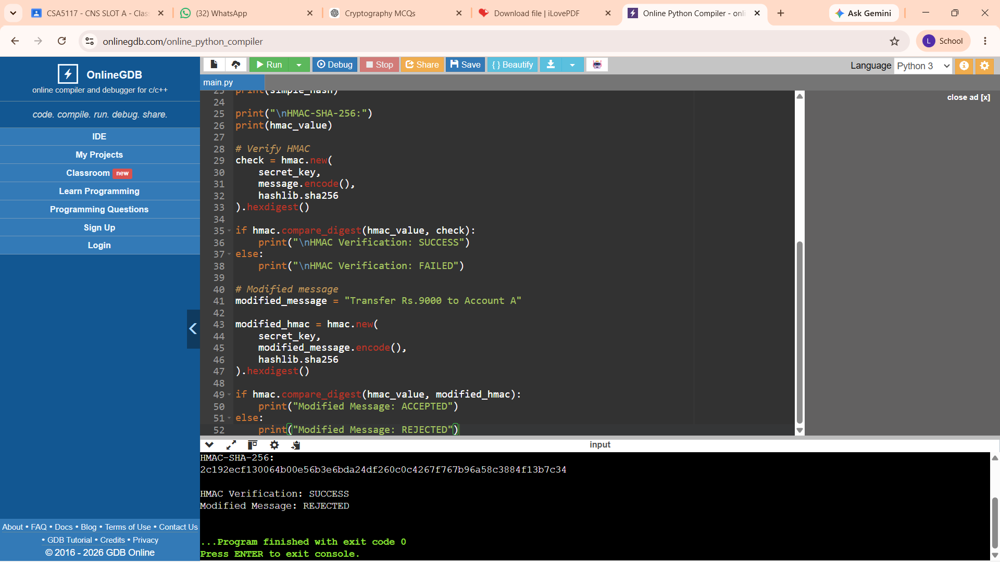

EXPERIMENT 4: SIMPLIFIED KERBEROS AUTHENTICATION
Program
import hashlib
import time

CLIENT_SECRET = "CLIENT_SECRET"

# Generate ticket
def generate_ticket(username):

timestamp = int(time.time())

ticket_data = f"{username}|{timestamp}"

ticket_hash = hashlib.sha256(
(ticket_data + CLIENT_SECRET).encode()
).hexdigest()

return ticket_data, ticket_hash

# Validate ticket
def validate_ticket(ticket_data, ticket_hash):

expected_hash = hashlib.sha256(
(ticket_data + CLIENT_SECRET).encode()
).hexdigest()

# Check authenticity
if ticket_hash != expected_hash:
return False

username, timestamp = ticket_data.split("|")

current_time = int(time.time())

# Ticket lifetime = 10 seconds
if current_time - int(timestamp) > 10:
return False

return True

# Client requests ticket
username = "Lavanya"

ticket_data, ticket_hash = generate_ticket(username)

print("Generated Ticket:")
print(ticket_data)

print("\nTicket Hash:")
print(ticket_hash)

# Server validates ticket
if validate_ticket(ticket_data, ticket_hash):
print("\nAuthentication: SUCCESS")
else:
print("\nAuthentication: FAILED")

# Replay attack simulation
print("\nWaiting for ticket to expire...")
time.sleep(11)

print("Replay Attack Test:")

if validate_ticket(ticket_data, ticket_hash):
print("Replay Attack: ACCEPTED")
else:
print("Replay Attack: BLOCKED")

OUTPUT
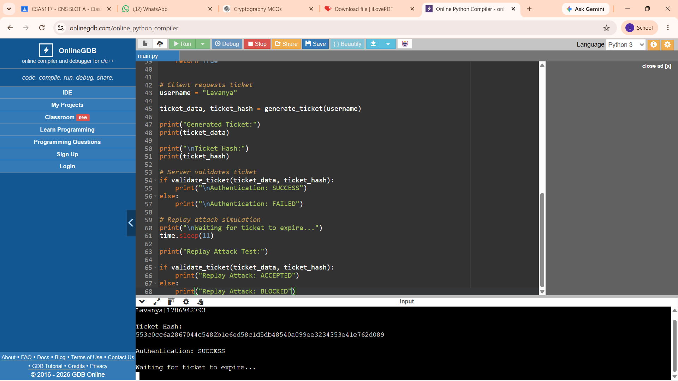

EXPERIMENT 5: ELGAMAL DIGITAL SIGNATURE
Program
import hashlib
import math

# Public parameters
p = 467
g = 2

# Private key
x = 127

# Public key
y = pow(g, x, p)

message = "Secure Digital Signature"

# Hash message
h = int(
hashlib.sha256(message.encode()).hexdigest(),
16
) % (p - 1)

# Signing value
k = 3

while math.gcd(k, p - 1) != 1:
k += 1

# Calculate r
r = pow(g, k, p)

# Calculate inverse of k
k_inverse = pow(k, -1, p - 1)

# Calculate s
s = ((h - x * r) * k_inverse) % (p - 1)

print("Public Parameters")
print("p =", p)
print("g =", g)

print("\nPublic Key:", y)
print("Private Key:", x)

print("\nMessage:", message)
print("Signature:", (r, s))

# Verification
left = pow(g, h, p)

right = (
pow(y, r, p) *
pow(r, s, p)
) % p

print("\nVerification")
print("Left :", left)
print("Right:", right)

if left == right:
print("Signature Verification: SUCCESS")
else:
print("Signature Verification: FAILED")

OUTPUT
